**SQL-Mongo Project – Spatial Data of US Wildfires**

Contents

Assumptions/Notes About Data Entities and Relationships 3

Entity-Relationship Diagram 3

Data in the Database 4

Query 1 7

Question 7 7

Notes/Comments About SQL Query and Results (Include # of Rows in Result) 7

Translation 7

Cleanup 7

Screen Shot of SQL Query and Results 7

Query 2 8

Question 1 8

Notes/Comments About SQL Query and Results (Include # of Rows in Result) 8

Translation 8

Screen Shot of SQL Query and Results 8

Query 3 9

Question 3 9

Notes/Comments About SQL Query and Results (Include # of Rows in Result) 9

Translation 9

Screen Shot of SQL Query and Results 9

Query 4 10

Question 6 10

Notes/Comments About SQL Query and Results (Include # of Rows in Result) 10

Translation 10

Screen Shot of SQL Query and Results 10

Query 5 11

Question 8 11

Notes/Comments About SQL Query and Results (Include # of Rows in Result) 11

Translation 11

Screen Shot of SQL Query and Results 11

Query 6 12

Question 2 12

Notes/Comments About SQL Query and Results (Include # of Rows in Result) 12

Translation 12

Screen Shot of SQL Query and Results 12

Assumptions/Notes About Data Collections, Attributes and Relationships between Collections 13

Assumptions/Notes About Data Set 14

Screen shot of Physical Database objects (Database, Collections and Attributes) 14

Data in the Database 14

Query 1 15

Question 7 15

Notes/Comments About MongoDB Query/Code and Results (Include # of Documents in Result) 15

Translation 15

Screen Shot of MongoDB Query/Code and Results 15

-Query 2 16

Question 1 16

Notes/Comments About MongoDB Query/Code and Results (Include # of Documents in Result) 16

Translation 16

Screen Shot of MongoDB Query/Code and Results 16

Query 3 17

Question 3 17

Notes/Comments About MongoDB Query/Code and Results (Include # of Documents in Result) 17

Translation 17

Screen Shot of MongoDB Query/Code and Results 17

Query 4 18

Question 6 18

Notes/Comments About MongoDB Query/Code and Results (Include # of Documents in Result) 18

Translation 18

Screen Shot of MongoDB Query/Code and Results 18

Query 5 19

Question 8 19

Notes/Comments About MongoDB Query/Code and Results (Include # of Documents in Result) 19

Translation 19

Screen Shot of MongoDB Query/Code and Results 19

Query 6 20

Question 2 20

Notes/Comments About MongoDB Query/Code and Results (Include # of Documents in Result) 20

Translation 20

Screen Shot of MongoDB Query/Code and Results 20

Data Model

## Assumptions/Notes About Data Entities and Relationships

1. The main fires table has been split into two tables as Fire incidents reported from Active agency(fire_act_agency) and Non-Active agency(fire_notact_agency). The creation of two separate tables was based on the availability of agency details in NWCG_UnitIDActive_20170109 table . On analysis we found USDESFM, USIASFM, USILSFM, USINSFM, USKSSFM, USKSJA409, USMASFM, USMOSFM, USNDSFM, USOHSFM, USVTSFM, USHIHIS to be notactive agencies and rest as active.
2. The NWCG table is also split into two tables based on US and non-US countries from NWCG_UnitIDActive_20170109 table
3. The latitude and longitude columns have been concatenated as Long_lat and taken as a Primary key.
4. The Gacc and GeographicArea have also been concatenated as Geo_Area_Coord_Centres and taken as Primary key.
5. All non-key columns depend only on primary key of the tables.
6. All tables have a primary key

## Entity-Relationship Diagram

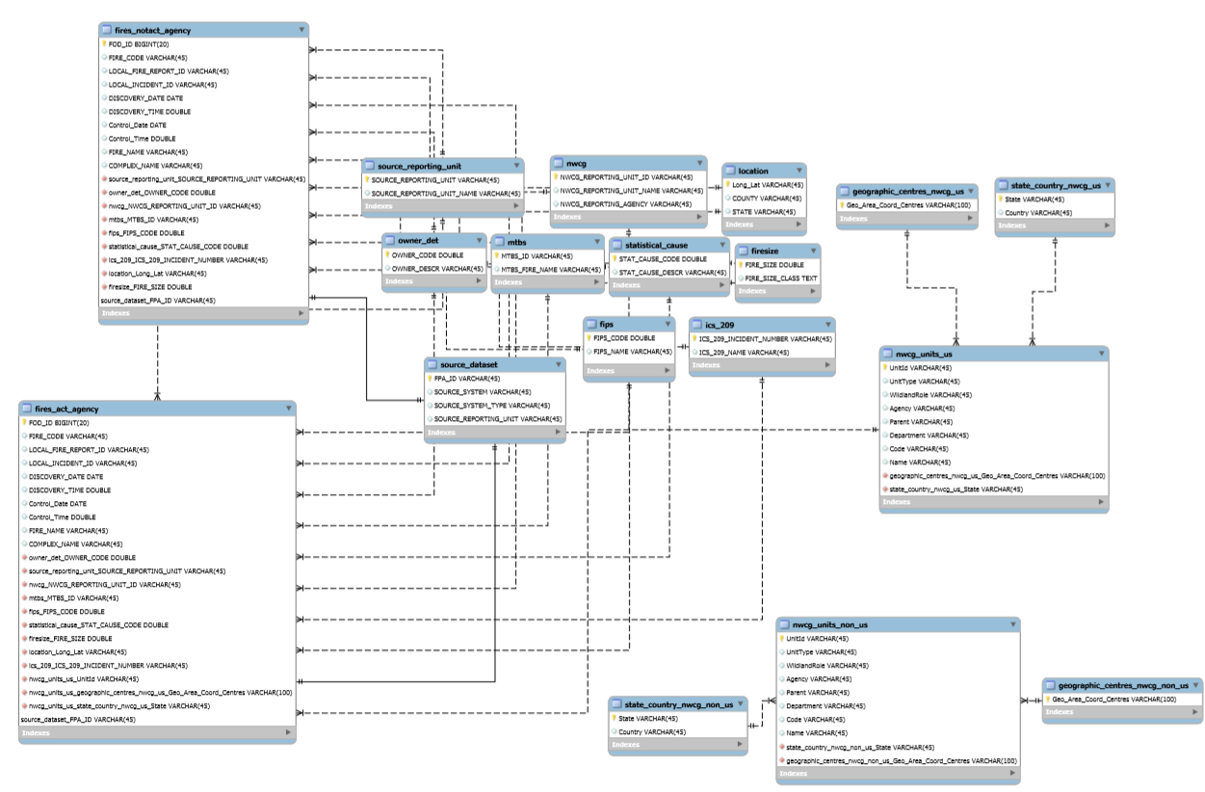

Physical Database

## Data in the Database

|  |  |  |  |
| --- | --- | --- | --- |
| **Table Name** | **Primary Key** | **Foreign Key** | **# of Rows in Table** |
| Fires_notact_agency | FOD_ID | Owner_det_OWNER_CODE, Source_reporting_unit_SOURCE_REPORTING_UNIT, Nwcg_NWCG_REPORTING_UNIT_ID,Mtbs_MTBS_ID,  Location_Long_Lat,Statistical_cause_STAT_CAUSE_CODE, Fips_FIPS_CODE,Firesize_FIRE_SIZE,Ics_209_ICS_209_INCIDENT_NUMBER | 1877095 |
| Fires_act_agency | FOD_ID | Owner_det_OWNER_CODE, Source_reporting_unit_SOURCE_REPORTING_UNIT, Nwcg_NWCG_REPORTING_UNIT_ID,Mtbs_MTBS_ID,  Location_Long_Lat,Statistical_cause_STAT_CAUSE_CODE, Fips_FIPS_CODE,Firesize_FIRE_SIZE,Ics_209_ICS_209_INCIDENT_NUMBER,nwcg_units_us_UnitId,nwcg_units_us_geographic_centres_nwcg_us_Geo_Area_Coord_Centres,nwcg_units_us_State_Country_nwcg_us_State | 3370 |
| Source_reporting_unit | SOURCE_REPORTING_UNIT |  | 6767 |
| Owner_det | OWNER_CODE |  | 16 |
| Source_dataset | FPA_ID |  | 1880463 |
| Nwcg | NWCG_REPORTING_UNIT_ID |  | 1640 |
| Mtbs | MTBS_ID |  | 10482 |
| Location | Long_Lat |  | 1585927 |
| Statistical_cause | STAT_CAUSE_CODE |  | 13 |
| Fips | FIPS_CODE |  | 2694 |
| Firesize | FIRE_SIZE |  | 13602 |
| Ics_209 | ICS_209_INCIDENT_NUMBER |  | 23314 |
| Geographic_centres_nwcg_us | Geo_Area_Coord_Centres |  | 13 |
| State_country_nwcg_us | State |  | 55 |
| Nwcg_units_us | UnitId | Geographic_centres_nwcg_us_Geo_Area_Coord_Centres,State_country_nwcg_us_State | 5852 |
| State_country_nwcg_non_us | State |  | 13 |
| Nwcg_units_non_us | UnitId | Geographic_centres_nwcg_non_us_ Geo_Area_Coord_Centres, State_country_nwcg_non_us_State | 15 |
| Geographic_centres_nwcg_non_us | Geo_Area_Coord_Centres |  | 2 |

SQL Queries

## Query 1

### Question 7

Which state had more fires in the first half of a calendar year than the second half of the calendar year?

### Notes/Comments About SQL Query and Results (Include # of Rows in Result)

This shows the states that have more fires in the first half of the calendar year compared to the second half of the calendar year (40 rows)

### Translation

Create two tables M1 and M2 such that it contains the fires incidents and state details for the First half of the calendar year and second half of the calendar year respectively.

Select the state, the number of fires in the first half of the calendar year from M1 table and number of fires in second half of the table from M2 where number of fires in M1 is greater than M2

### Cleanup

* Create table M1 as Select STATE, count of FOD.ID where month is less than equal to 6 and group by STATE
* Create table M2 as Select STATE, count of FOD.ID where month is greater than 6 and group by STATE
* Select M1.STATE , M1.No_of_Fires as First_Half and M2.No_of_Fires as Second_Half from M1 and join M2 on M1.STATE equal to M2.STATE where M1.No_of_Fires is greater than M2.No_of_Fires

### Screen Shot of SQL Query and Results

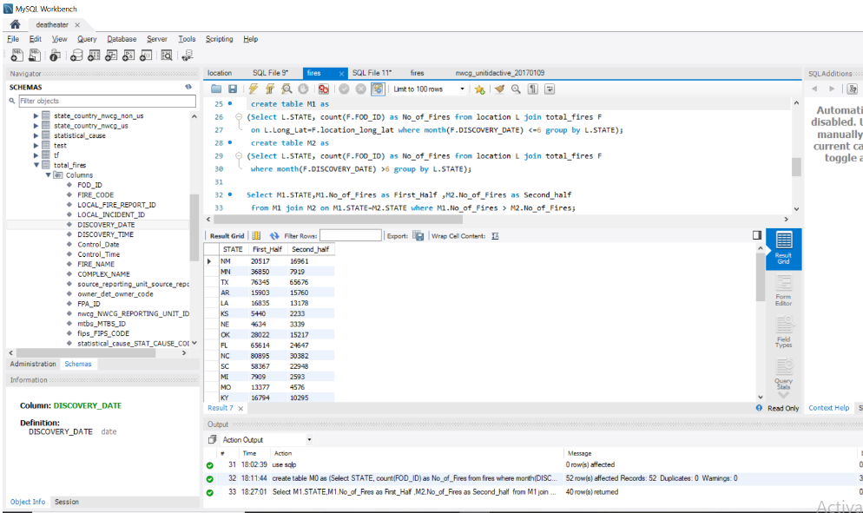

## Query 2

### Question 1

A leading beverage company has announced a billion-dollar fund for removing debris from forests, rivers and mountains in the US. All states are interested. Which state has the least chance to win a share of the fund?

### Notes/Comments About SQL Query and Results (Include # of Rows in Result)

This shows that state DC has the least chance to win the share of the fund. (1 Row)

### Translation

Select the State where the cause of forest fire is due to debris burning

Cleanup

* Select minimum of No_of_Fires which is in subquery A and STATE from
* Select the count of FOD_ID and STATE from total_fires table
* where statistical_Cause_STAT_CAUSE_CODE is equal to 5 (debris burning) and group by STATE

### Screen Shot of SQL Query and Results

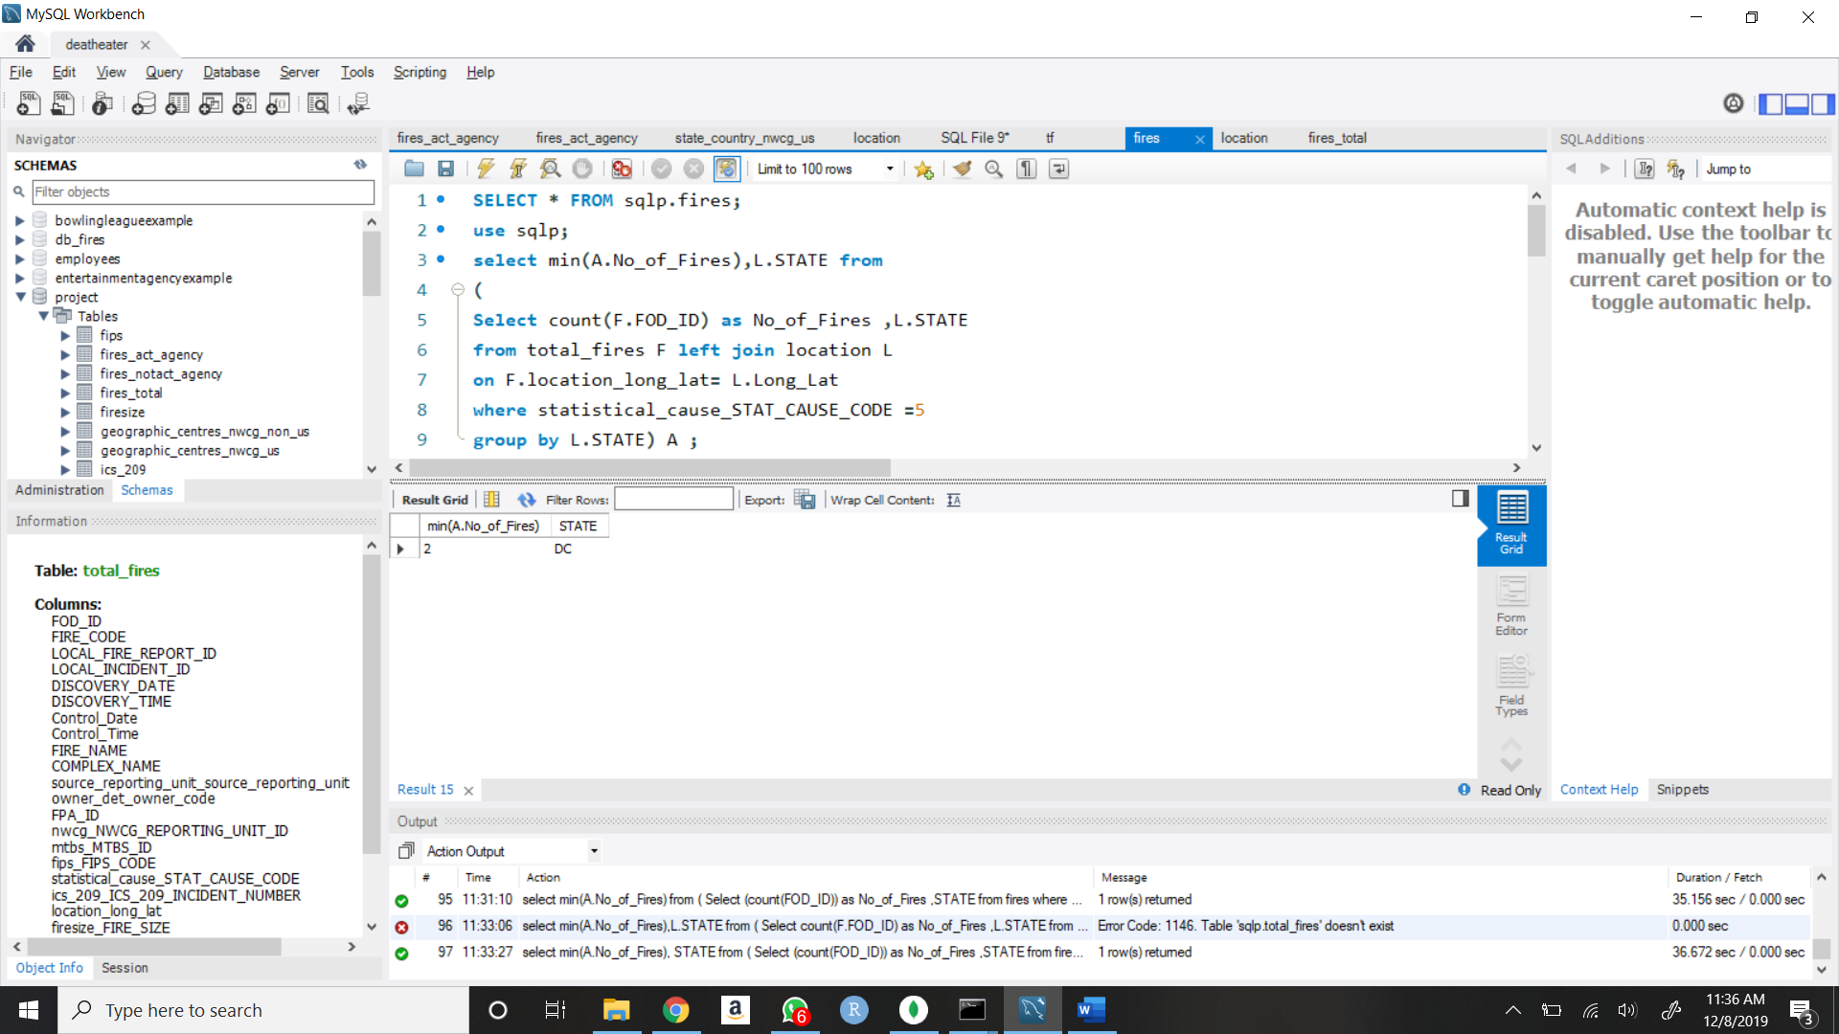

## Query 3

### Question 3

One advocacy group says human actions and not Nature is to blame for most wildfires. Write a query that supports this statement.

### Notes/Comments About SQL Query and Results (Include # of Rows in Result)

Shows the list of all incidents which are due to human actions is more than the number of incidents due to natural causes like lightning.(13 Rows)

### Translation

Select the number of incidents and the statistical cause code and description

Cleanup

* Select total row count as No_of_incidents, STAT_CAUSE_CODE and STAT_CAUSE_DESCR in a subquery and grouped by statistical_Cause_STAT_CAUSE_CODE.
* From created table F3 joined based on STAT_CAUSE_CODE

### Screen Shot of SQL Query and Results

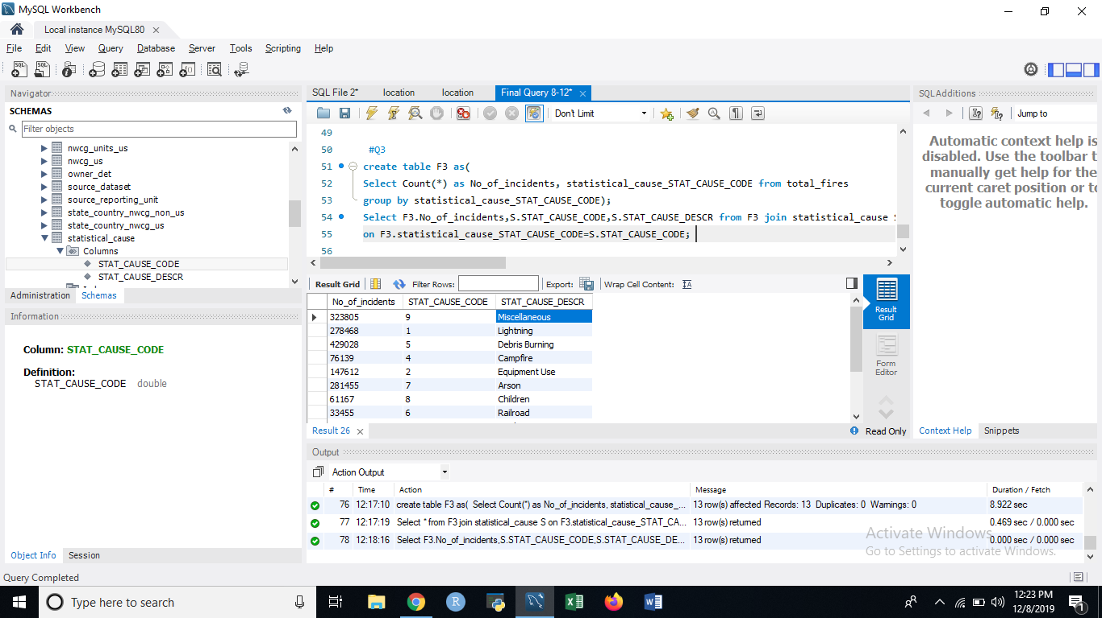

## Query 4

### Question 6

What were the forests that had no fires that lasted more than two days?

### Notes/Comments About SQL Query and Results (Include # of Rows in Result)

Shows the list of forests that had no fires that lasted for more than 2 days (1220 Rows)

### Translation

Select the Name of the forest and nwcg reporting unit id where fires had lasted less than 3 days

Cleanup

* Add a column No_of_Days to the total_fires table
* Update total_fires as No_of_Days is the difference between Control_Date and DISCOVERY_DATE
* Select distinct values of nwcg_NWCG_REPORTING_UNIT_ID as Unit_Id and No_of_Days from total_fires table where No_of_Days is less than 3 in a subquery in the created table F6
* Select distinct Name and UNIT_ID and order by Name

### Screen Shot of SQL Query and Results

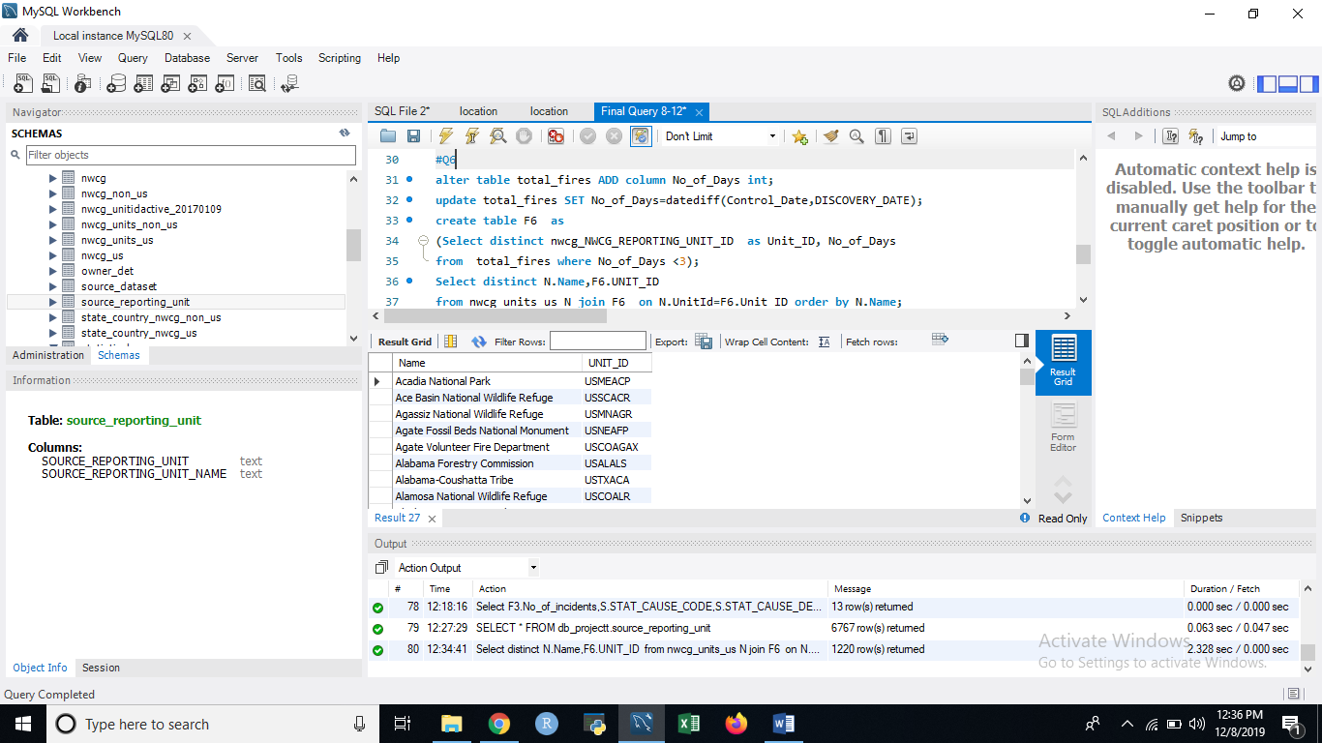

## Query 5

### Question 8

Which forest had the least number of fires?

### Notes/Comments About SQL Query and Results (Include # of Rows in Result)

Shows the list of forest that had the least fire incidents (197 Rows)

### Translation

Select the name and number of fires from nwcg units in US where the number of fires is equal to 1

Cleanup

* Select No_of_Fires and Unit_Id from subquery Select count of FOD_ID as No_of_Fires, nwcg_NWCG_REPORTING_UNIT_ID as Unit_Id from total_fires table and group by nwcg_NWCG_REPORTING_UNIT_ID
* Where the No_of_fires is equal to 1
* Select Name and No_of_Fires

### Screen Shot of SQL Query and Results

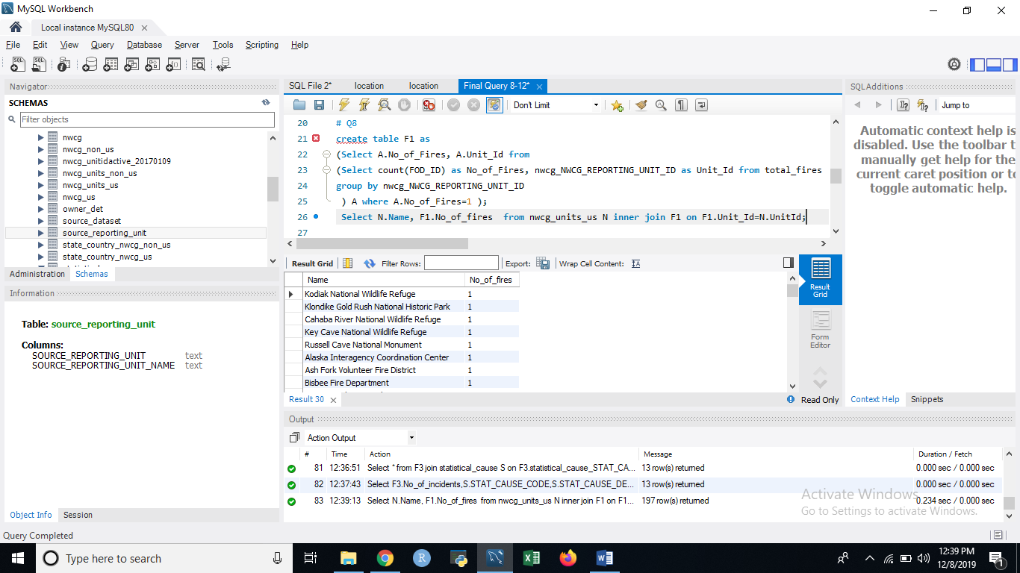

## Query 6

### Question 2

One of the reporting agencies has suggested that children be banned from its forests unless there is one adult for every 3 children in a group visiting a forest. Name 3 forests where this would be the least appropriate

### Notes/Comments About SQL Query and Results (Include # of Rows in Result)

Shows the names of the three forests where it would be least appropriate to suggest banning children unless there is one adult for every 3 children (3 Rows)

### Translation

Select the name of the forest and no of fires where statistical_Cause_STAT_CAUSE_CODE is equal to 8 and limit the list to 3

Cleanup

* Create a table Q3 as Select nwcg_NWCG_REPORTING_UNIT_ID and count of all records as No_of_fires from total_fires table where Statical_cause_STAT_CAUSE_CODE is equal to 8 and group by nwcg_NWCG_REPORTING_UNIT_ID and order by No_of_fires
* Select Name and No_of_fires from nwcg_units_us table and on the UnitId column and order by No_of_fires and Name and limit the result to 3

### Screen Shot of SQL Query and Results

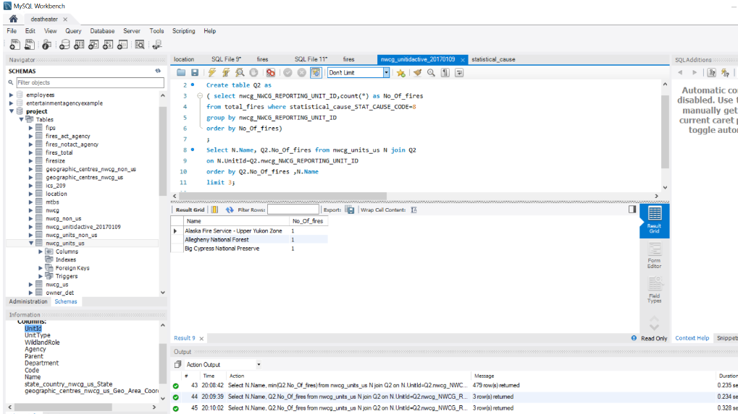

Data Review for MongoDB

## Assumptions/Notes About Data Collections, Attributes and Relationships between Collections

Since MongoDB is document based and hence does not require any normalization and row structure is not enforced by the table.

Physical Mongo Database

## Assumptions/Notes About Data Set

* Shape column not considered
* The order of the questions answered is jumbled. Kindly refer to question number indicated which corresponds to the questions set

## Screen shot of Physical Database objects (Database, Collections and Attributes)

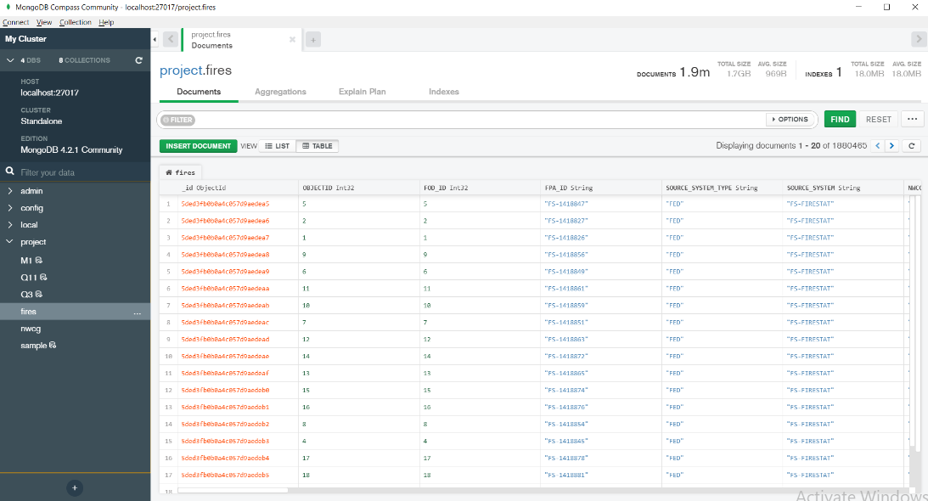

## Data in the Database

|  |  |  |
| --- | --- | --- |
| **Collection Name** | **Relationshps With Other Collections (if any)** | **# of Documents in Collection** |
| Fires |  | 1880465 |
| Nwcg |  | 5867 |

MongoDB Queries/Code

## Query 1

### Question 7

Which state had more fires in the first half of a calendar year than the second half of the calendar year?

### Notes/Comments About MongoDB Query/Code and Results (Include # of Documents in Result)

Showa the states for which the fires in the first half of the calendar year is more than that of the second half of the calendar year (40 Documents)

### Translation

* Select ids and value greater than difference between count and count2 from table1 joined on table2 based on id.

### Screen Shot of MongoDB Query/Code and Results

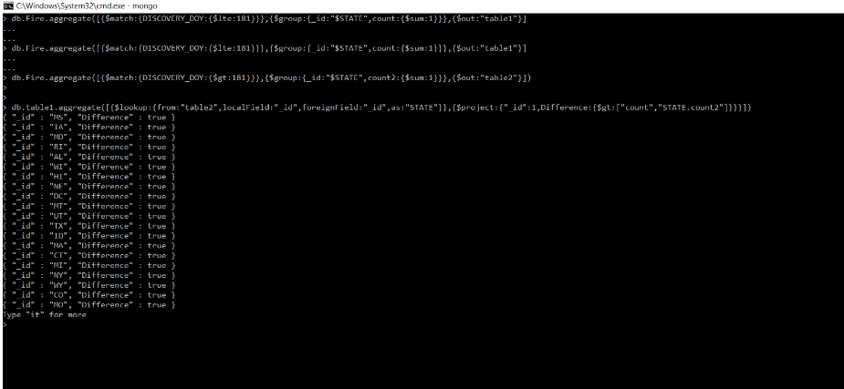

## -Query 2

### Question 1

A leading beverage company has announced a billion-dollar fund for removing debris from forests, rivers and mountains in the US. All states are interested. Which state has the least chance to win a share of the fund?

### Notes/Comments About MongoDB Query/Code and Results (Include # of Documents in Result)

Db.fires.aggregate([{$match:{STAT_CAUSE_DESCR:”Debris Burning”}},{$group:{_id:”$STATE”,count:{$sum:1}}},{$sort:{count:1,_id:1}},{$limit:1}])

(1 Document)

### Translation

* Select state and count of occurrence where stat_cause_descr is debris burning

### Screen Shot of MongoDB Query/Code and Results

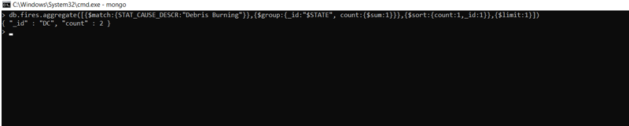

## Query 3

### Question 3

One advocacy group says human actions and not Nature is to blame for most wildfires. Write a query that supports this statement.

### Notes/Comments About MongoDB Query/Code and Results (Include # of Documents in Result)

Db.fires.aggregate([{$group:{_id:”$STAT_CAUSE_DESCR”,count:{$sum:1}}},{$project:{“_id”:1,count:1}}])

(13 Documents)

### Translation

* Select id and count from fires grouped on STAT_CAUSE_DESCR

### Screen Shot of MongoDB Query/Code and Results

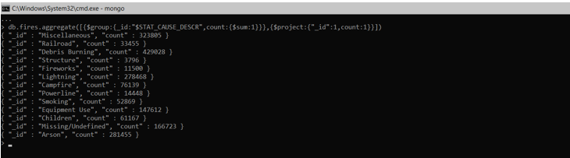

## Query 4

### Question 6

What were the forests that had no fires that lasted more than two days?

### Notes/Comments About MongoDB Query/Code and Results (Include # of Documents in Result)

Shows the list of forests that had no fires that lasted for more than 2 days (1220 Documents)

Db.fires.aggregate({$project:{NWCG_REPORTING_UNIT_NAME:1,DATE_DIFF:{$subtract:{[“$CONT_DOY”,”$DISCOVERY_DOY”]}}},{$match:{DATE_DIFF:{$lte:2}}},{$group:{_id:”$NWCG_REPORTING_UNIT_NAME”}})

### Translation

* Select NWCG_REPORTING_UNIT_NAME, DATE_DIFF from fires where date difference is less than 2 and then grouped on NWCG_REPORTING_UNIT_NAME

### Screen Shot of MongoDB Query/Code and Results

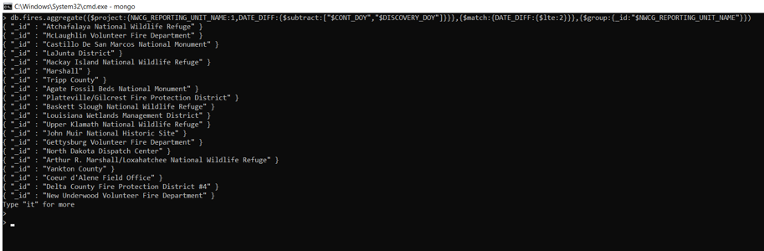

## Query 5

### Question 8

Which forest had the least number of fires?

### Notes/Comments About MongoDB Query/Code and Results (Include # of Documents in Result)

Shows the forests with the least number of fires (197 Documents)

Db.fires.aggrergate([$group:{_id:”$NWCG_REPORTING_UNIT_NAME”,COUNT:{$sum:1}}},{$sort:{COUNT:1}},{$match:{count:1}}])

### Translation

* Select forest count from fires where count is 1 sorted on count grouped on NWCG_REPORTING_UNIT_NAME

### Screen Shot of MongoDB Query/Code and Results

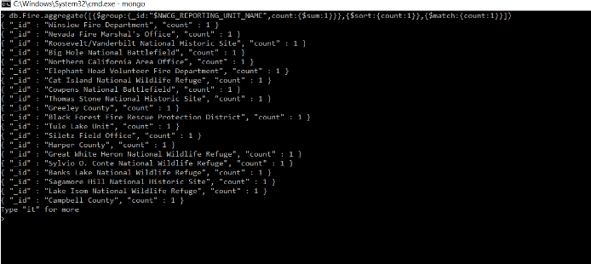

## Query 6

### Question 2

One of the reporting agencies has suggested that children be banned from its forests unless there is one adult for every 3 children in a group visiting a forest. Name 3 forests where this would be the least appropriate

### Notes/Comments About MongoDB Query/Code and Results (Include # of Documents in Result)

Name of the three forests where it would be least appropriate to suggest banning children unless there is one adult for every 3 children. (3 Documents)

Db.fires.aggregate9[{$match:{STAT_CAUSE_DESCR:”Children”}},{$group:{_id:”$NWCG_REPORTING_UNIT_NAME”,count:{$sum:1}}},{$sort:{count:1,”_id”:1}},{$limit:3}])

### Translation

* Select forest names from fires where STAT_CAUSE_DESCR is Children grouped on NWCG_REPORTING_UNIT_NAME limited to 3 records

### Screen Shot of MongoDB Query/Code and Results

